**Dear DeJean Families,**

Happy New Year! We were excited to welcome back the students last week, and we are looking forward to a great 2024! Here is what is happening this January:

**Academics:**

This is the final week of quarter 2 and Semester 1. Please check PowerSchool for the most current grades and support your student in completing any missing assignments. Additionally, students will be taking their second i-Ready benchmark exam starting January 17. The i-Ready test is an adaptive diagnostic assessment that helps determine a student's growth in Math and English. Based on the assessment results, students will be assigned personalized instruction to address any learning gaps. Please encourage your child to do their best so we have an accurate representation of their progress.

**Reminders:**

**Tablet Care:** We have seen an uptick of broken tablets and therefore have a minimal supply of replacements. Please remind your students to treat their tablets with care. Families will be billed for willful damages.

**Events:**

**January 11: AAPAC meeting (virtual) at 6 pm**

* The focus of this meeting will be to hear from our families about how we can best serve the needs of our African American students.

**January 15: MLK Holiday**

**January 16: Teacher Work Day (no school for students)**

**January 18: SSC Meeting at 6 pm**

* We will review our School Site Safety Plan and review our progress toward the SPSA goals.

**January 23: Digital Literacy Classes for Parent/Guardians: 5 to 7 pm**

* These classes are designed to teach parents and guardians the basics of digital literacy and educational programs such as PowerSchool so they can better support and monitor their students. Upon completion of 8 hours, participants receive a free laptop! If you are interested, please sign up here. Space is limited!

**January 25: Mobile Dentist Clinic; Big Smiles**

* This is a chance for students to receive dental care while at school. For more information and to sign up your student, go to [www.myschooldentist.com](https://urldefense.com/v3/__https://www.myschooldentist.com/__;!!OZEuhTV5Po1-xdhMVz0!E6bE1wJfgJM2VyWpfU7VRUNLVyiBwFdUfzpmkZJEbTysk6NUkhXxo5cDJ4AZWWuQYhfpfgdndQ4J9PrhPZY-ofCyME2FHw$).

**January 26: Coffee Chat with the Principal at 9 am**

* Come have some pastries and coffee and chat with Principal Valdez! There will also be a short presentation about the ELPAC and i-Ready exams.

**January 26: TRACKS Spirit Rally**

* Our rallies are a chance to build community and celebrate our students. We will also be reiterating the Schoolwide Expectations: Trustworthy, Respectful, Accountable, Curious, Kind and Safe (TRACKS)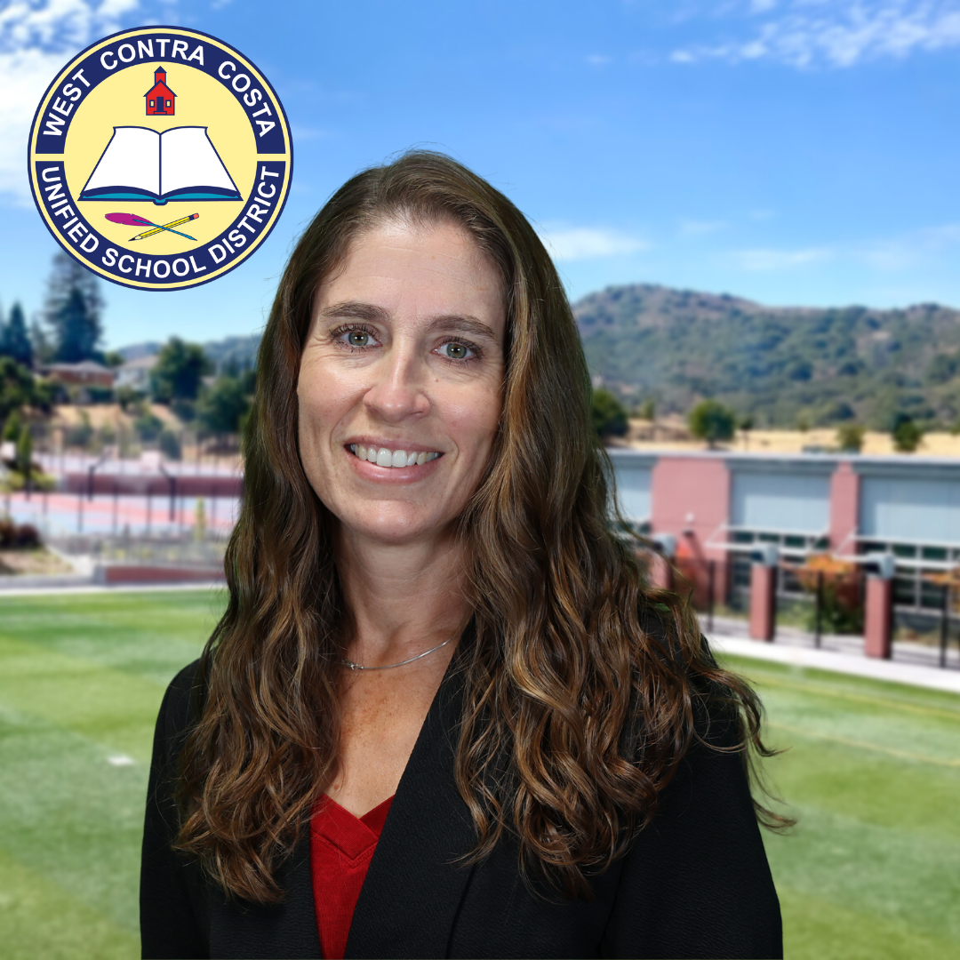

In Solidarity,

Athena Valdez

Principal